FINAL PROJECT BOOTCAMP SEASON 2

Anggota-Anggota Kelompok :

1. JasMaths (JasonMatthew) 🡪Ketua kelompok
2. James Martin 🡪 Wakil ketua 1
3. Kevinnnnn (Kevin) 🡪 Wakil ketua 2
4. Dody Harianto (bluewarrior)
5. Bryan Zheng (Spicy)
6. Louis R (LOUIII)
7. Felix M (FelixM)
8. Alfian Zurvi
9. Jeta
10. Kevin C
11. Louis O
12. Samuel

Jawaban :

1. Obscure Binary Search Tree

Jawab :

**Binary Search Tree** is a node-based binary tree data structure which has the following properties:

* The left subtree of a node contains only nodes with keys lesser than the node’s key.
* The right subtree of a node contains only nodes with keys greater than the node’s key.
* The left and right subtree each must also be a binary search tree.

1. Knight Trivials
2. Text Editor
3. Tree Simulations

a) AVL Tree

Insert 80, 35, 20, 100, 25, 30, 45, 40, 50, 37

Remove 35, 25, 30, 45, 80

Jawaban :

Insertion :

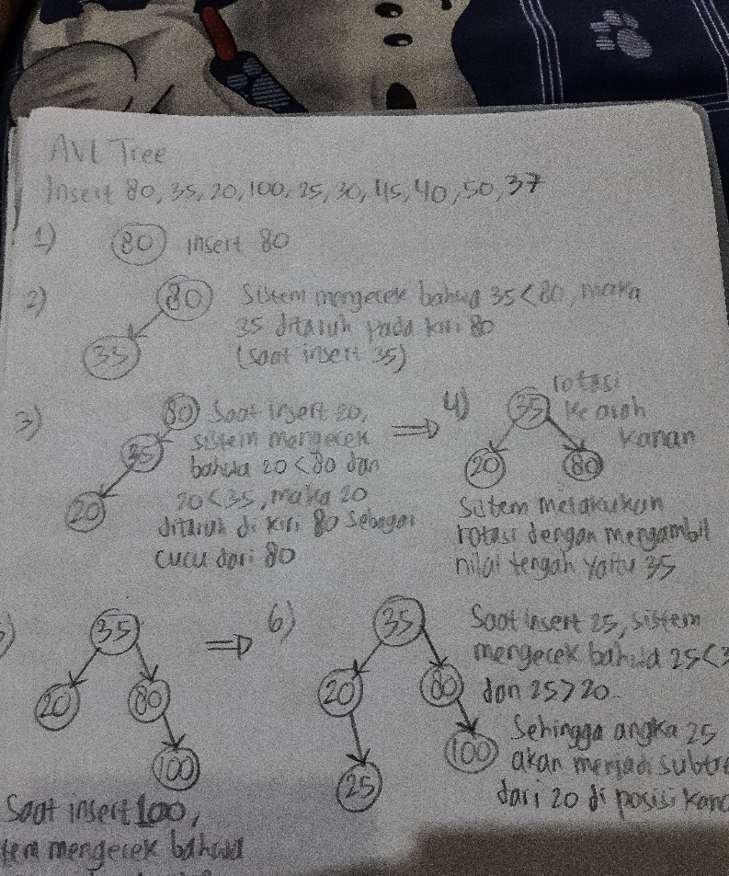

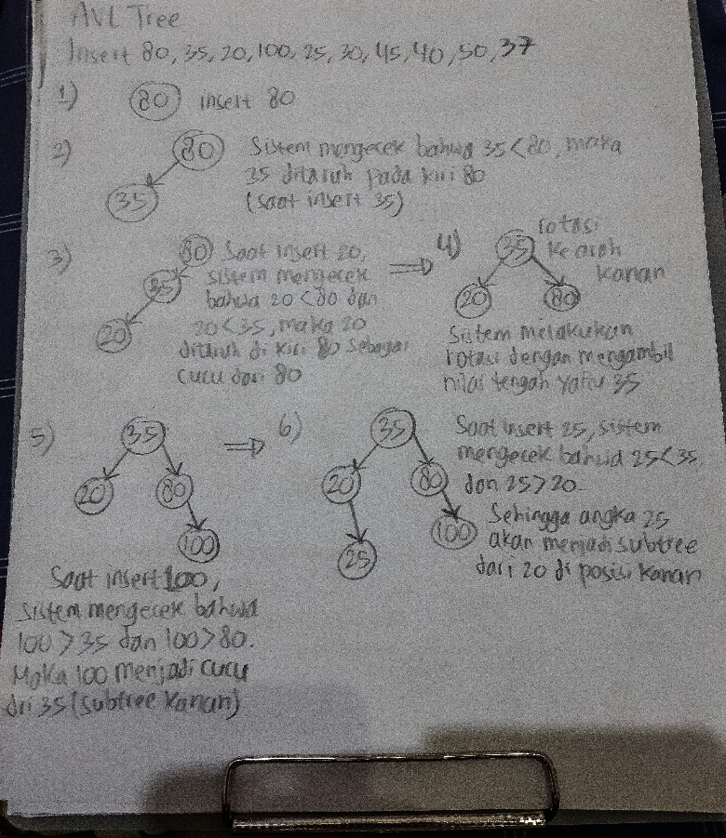

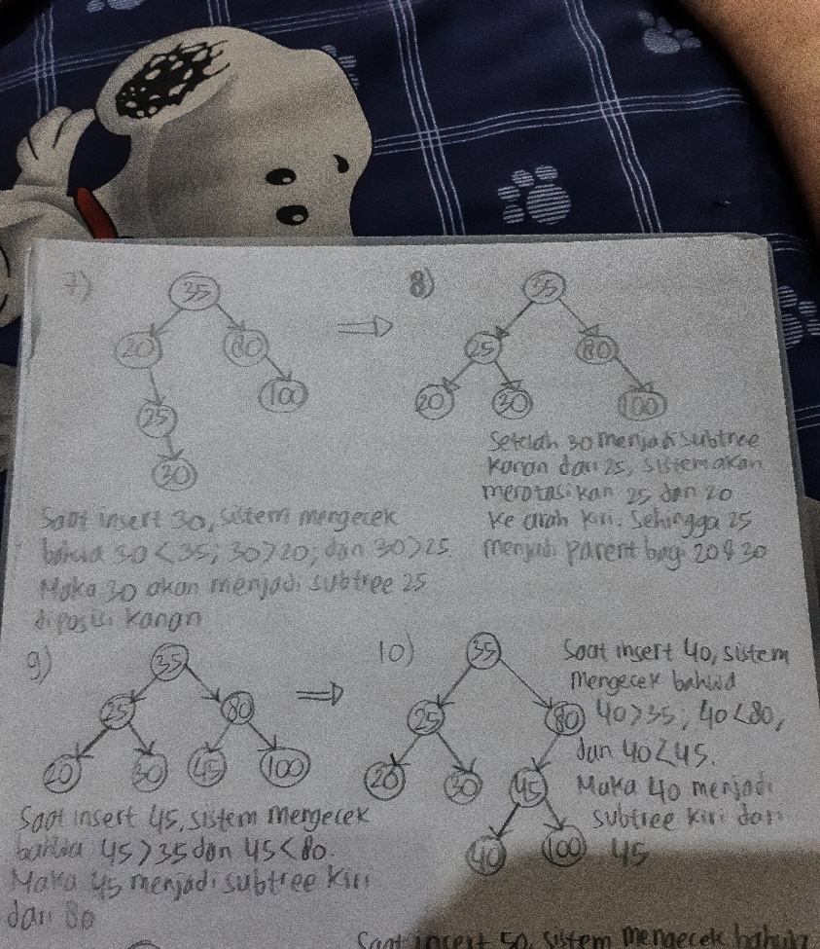

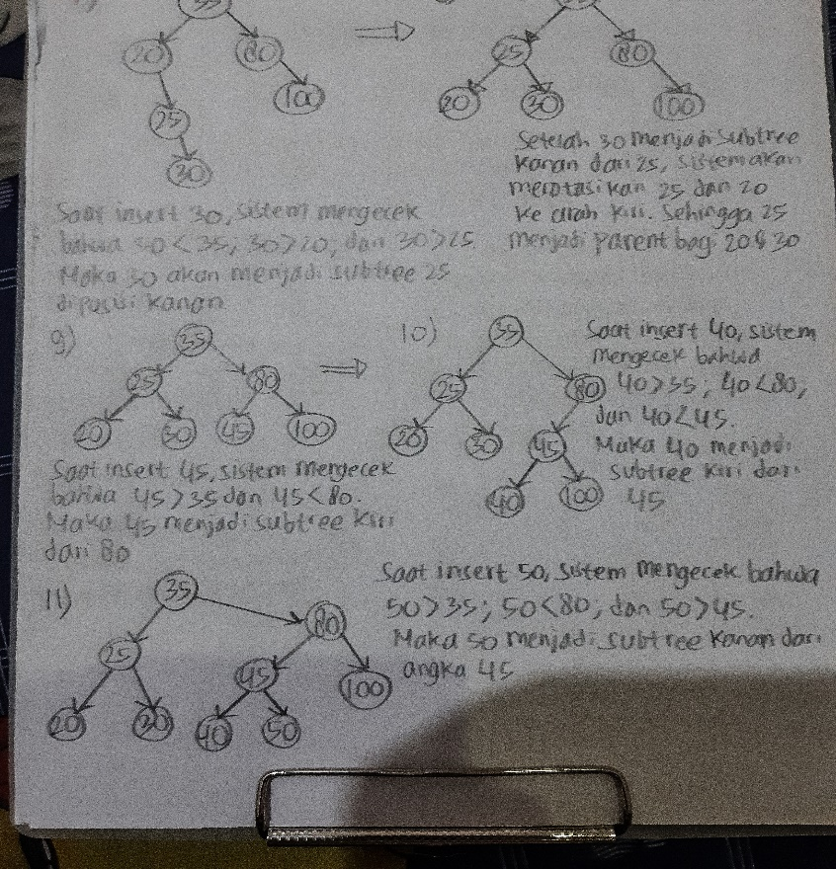

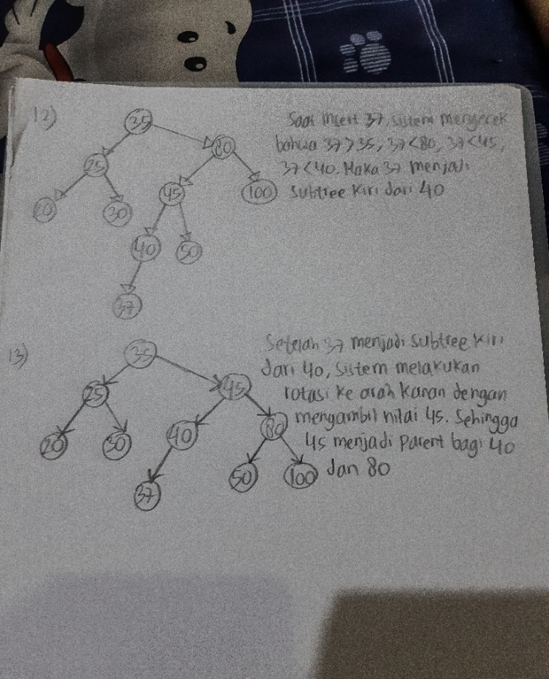

Deletion (for AVL tree) :

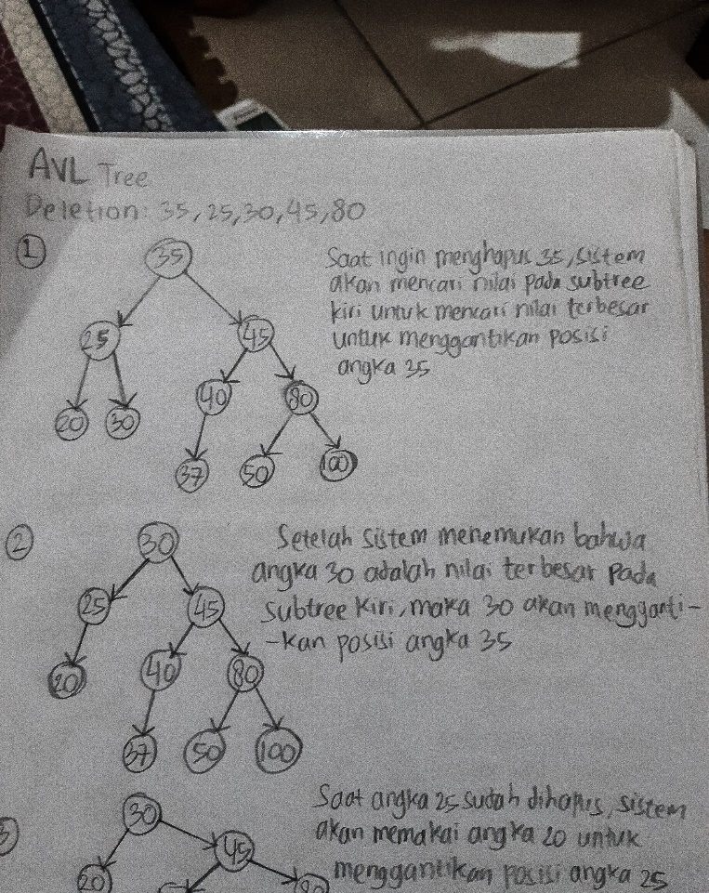

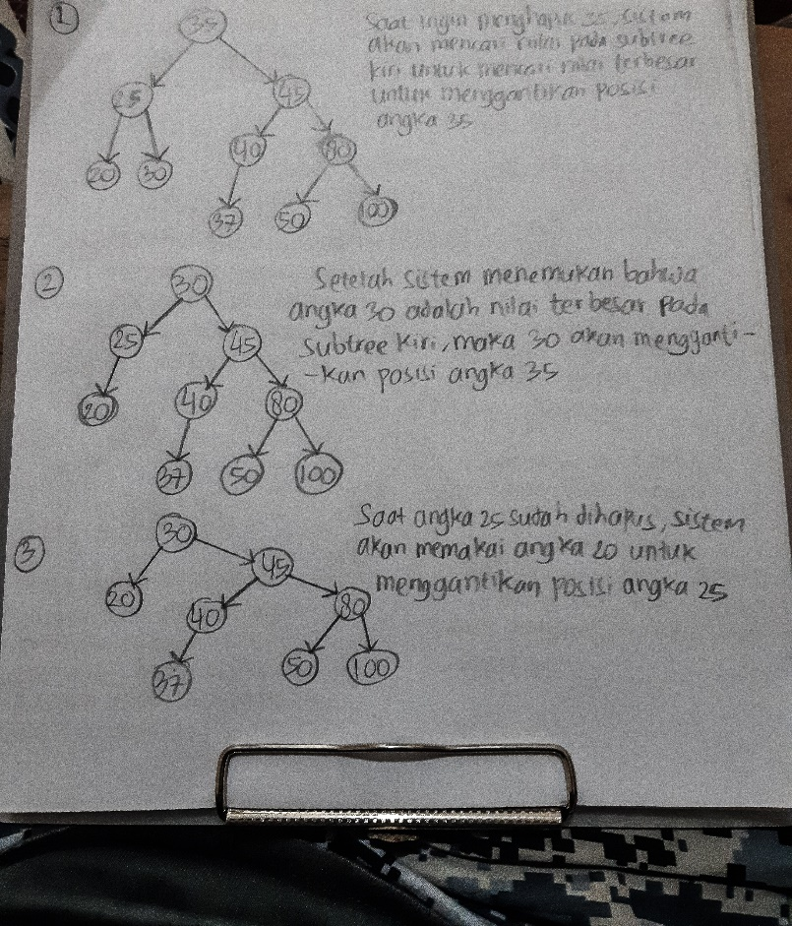

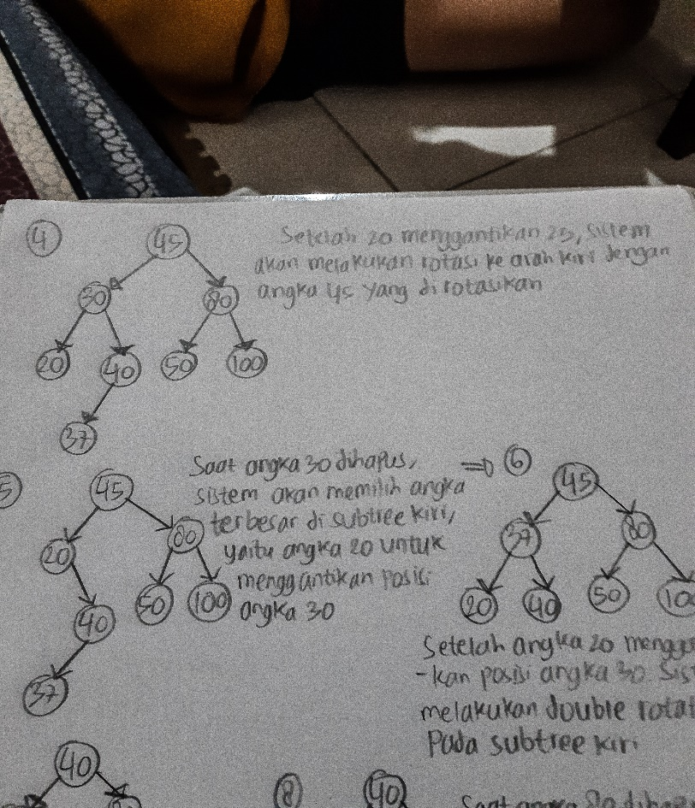

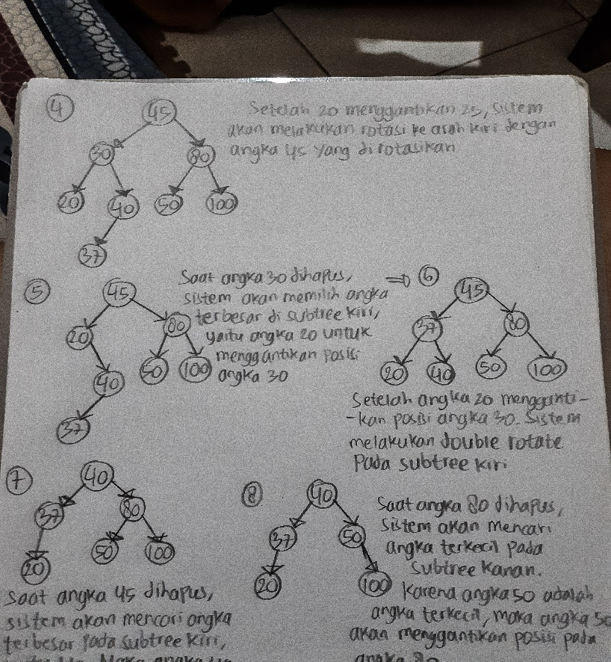

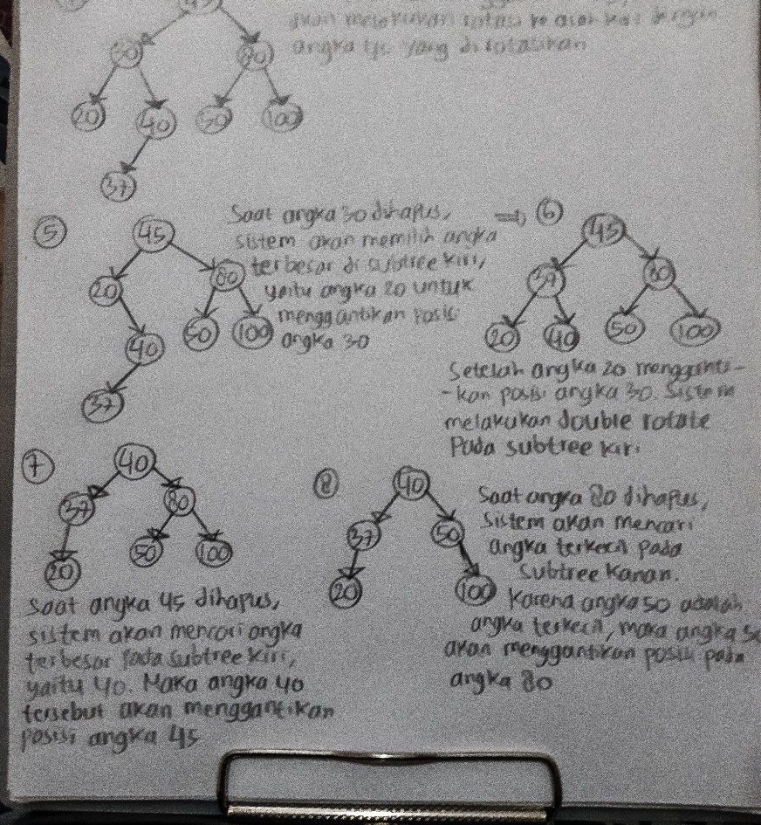

b) 2-3 Tree

Insert 80, 35, 20, 100, 25, 30, 45, 40, 50, 37

Remove 35, 25, 30, 45, 80

Jawaban :

Insertion (for 2-3 Tree) :

Deletion (for 2-3 Tree) :

c) Red-Black Tree

Insert 80, 35, 20, 100, 25, 30, 45, 40, 50, 37

Remove 35, 25, 30, 45, 80

Jawaban :

Insertion (Red-Black Tree) :

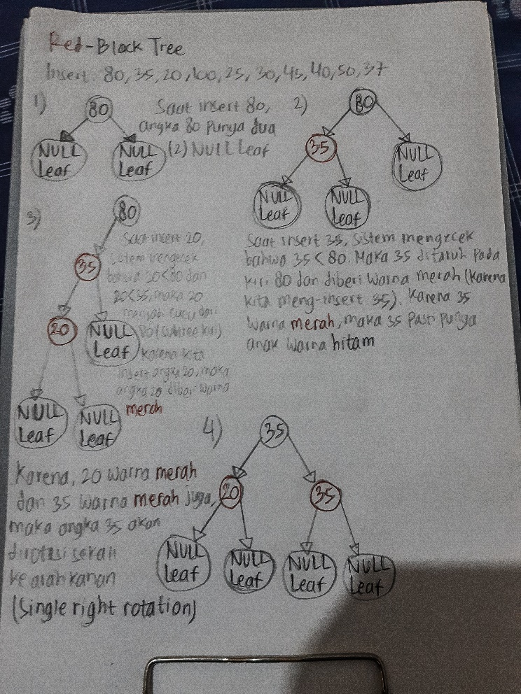

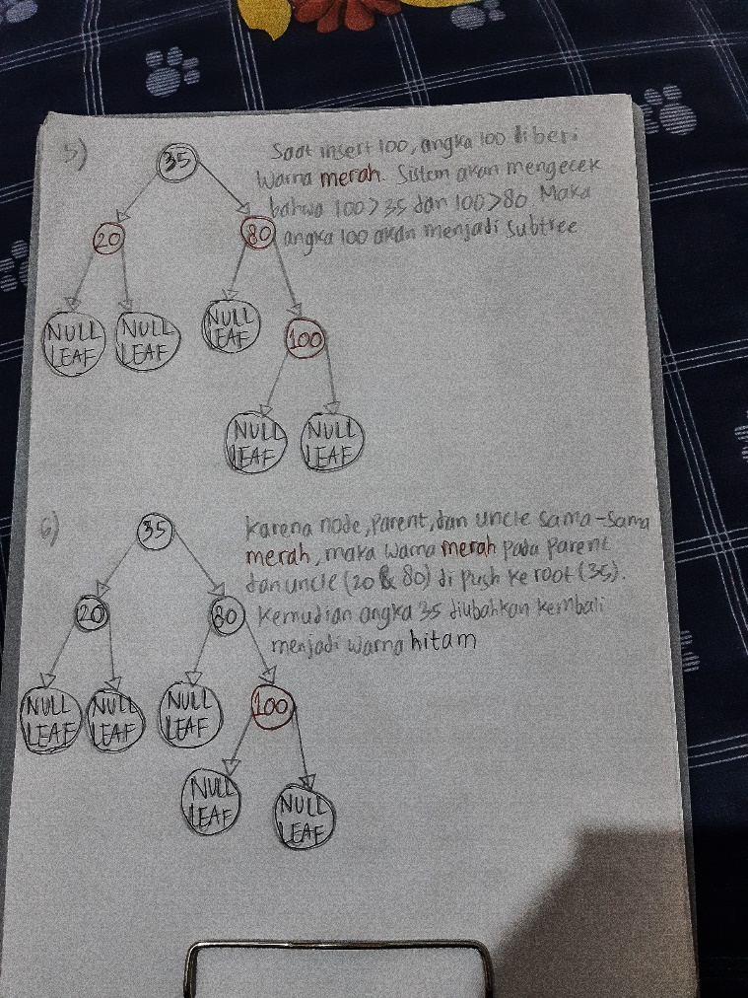

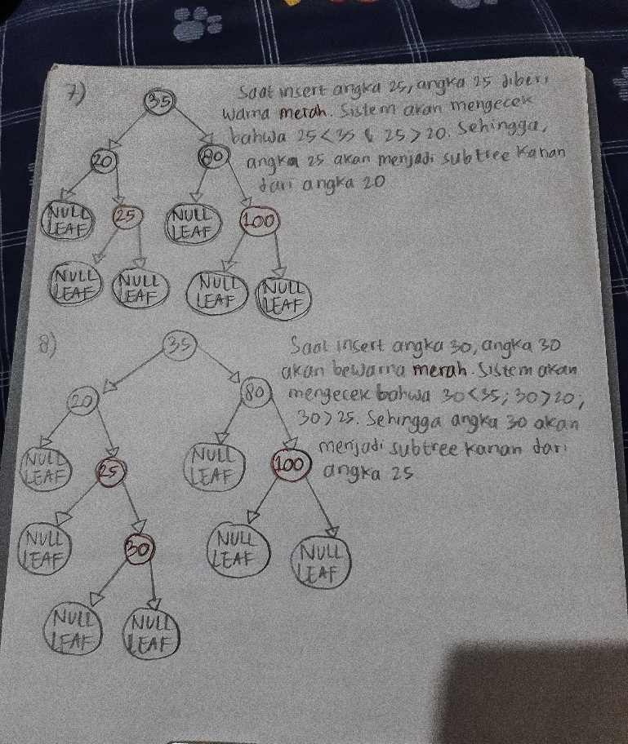

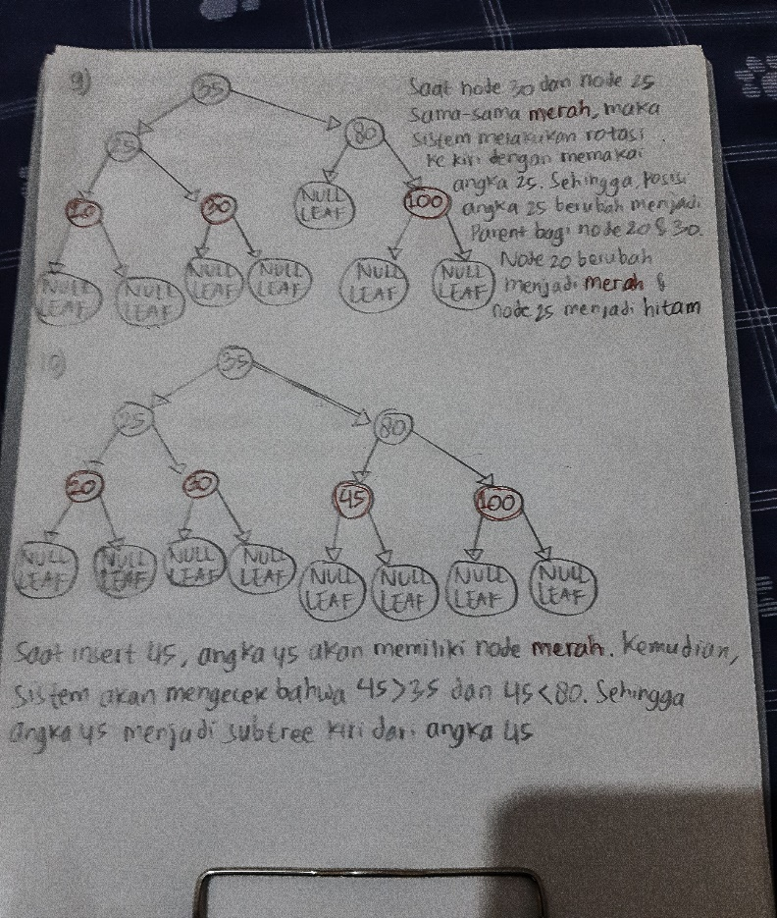

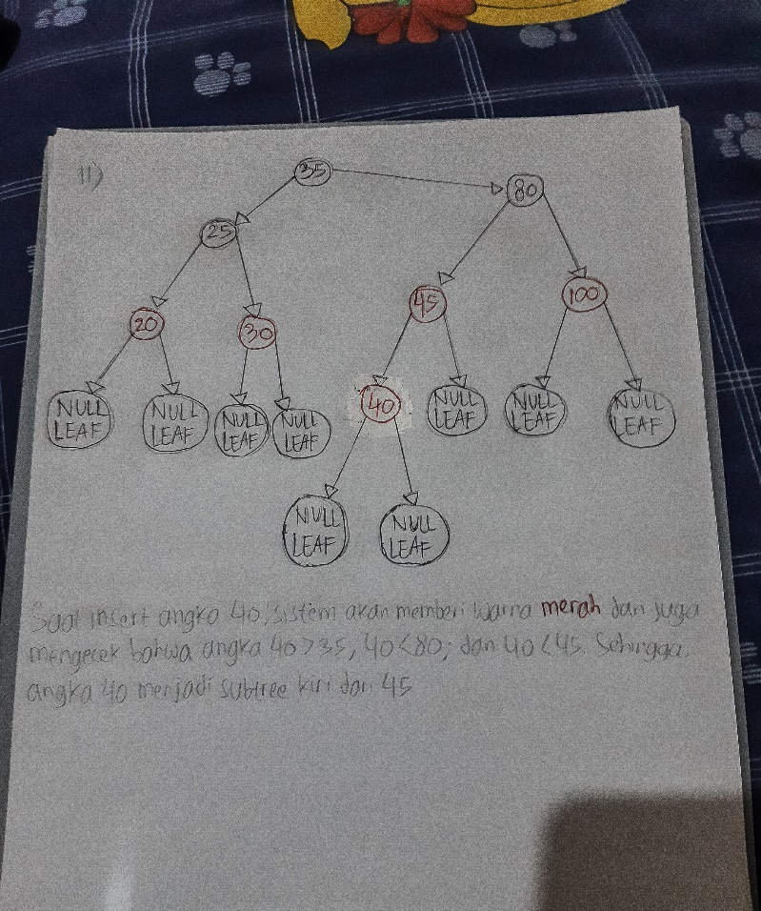

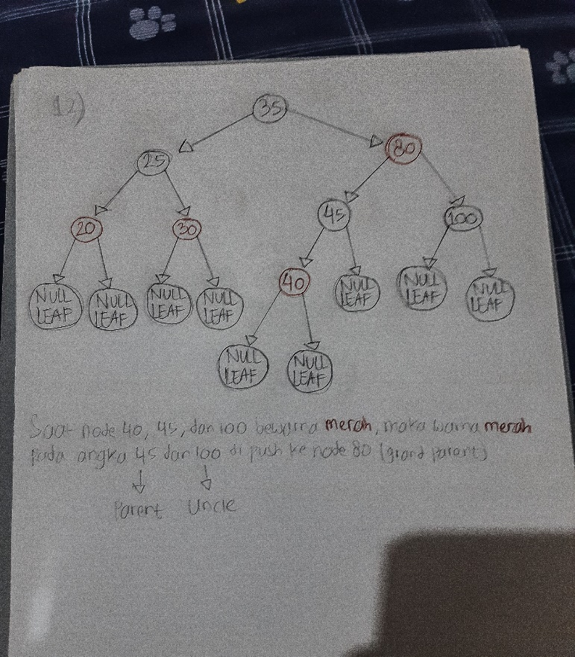

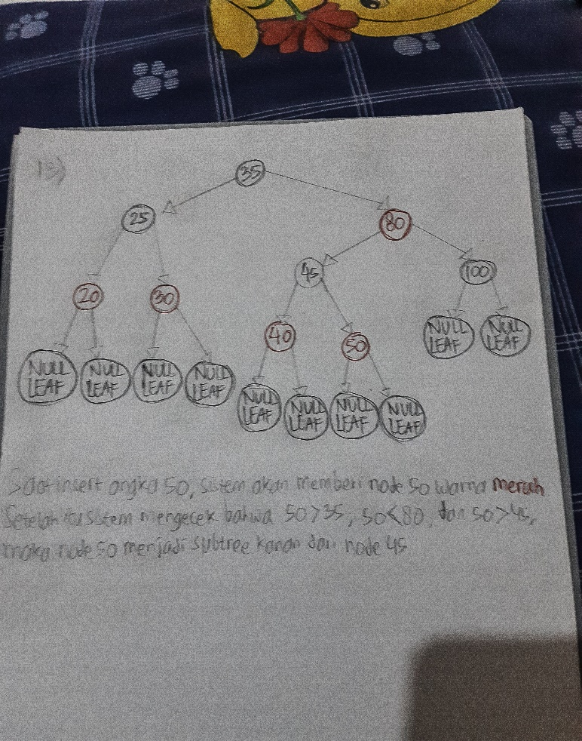

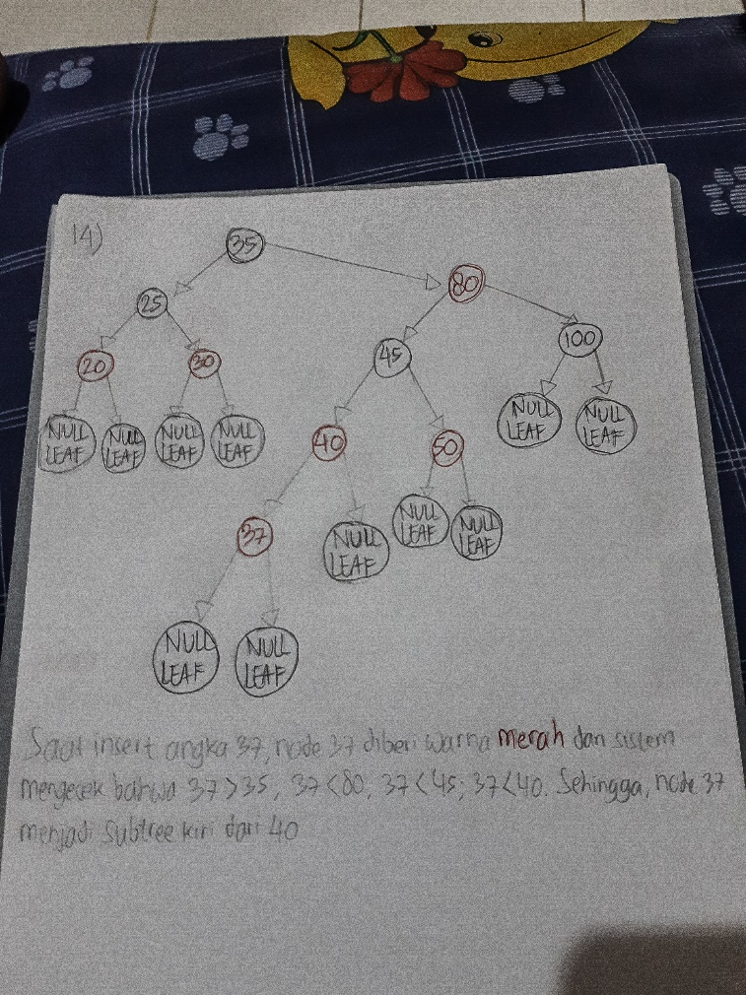

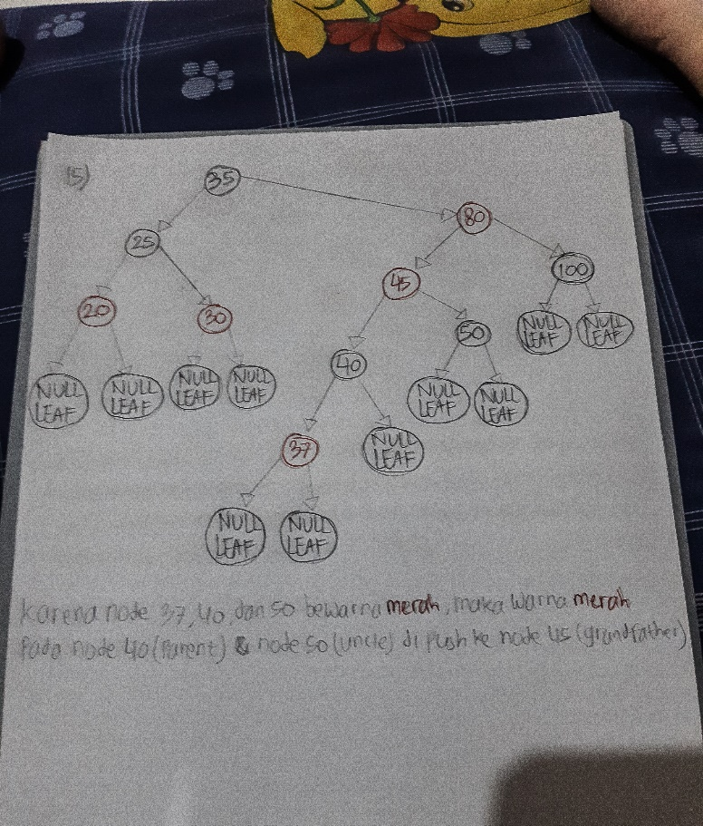

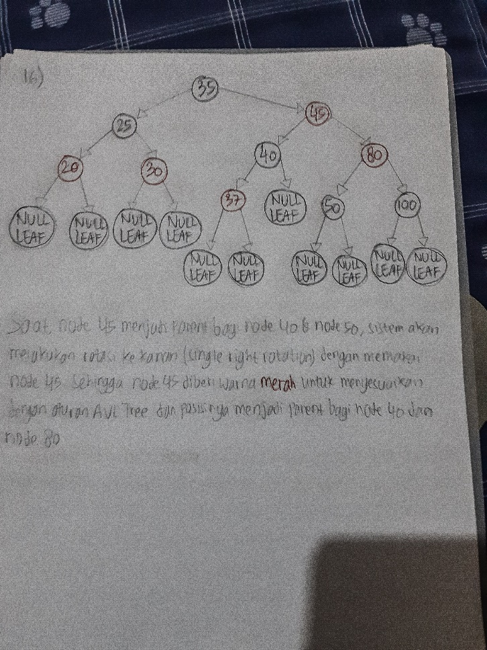

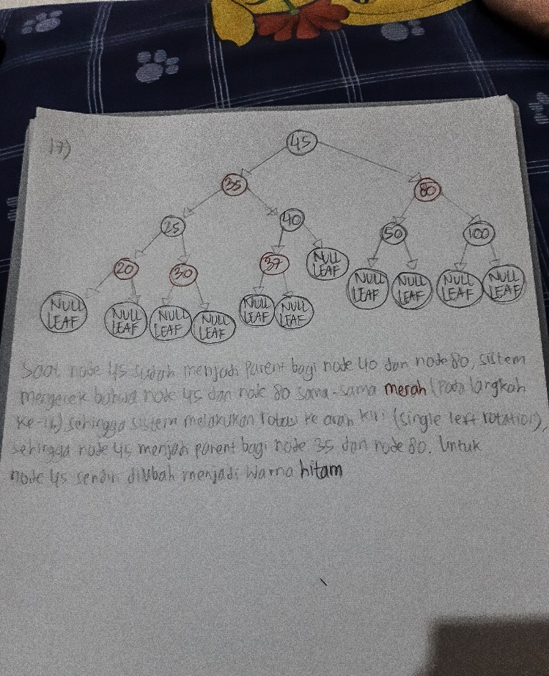

Remove (Red-Black Tree) : 35, 25, 30, 45, 80

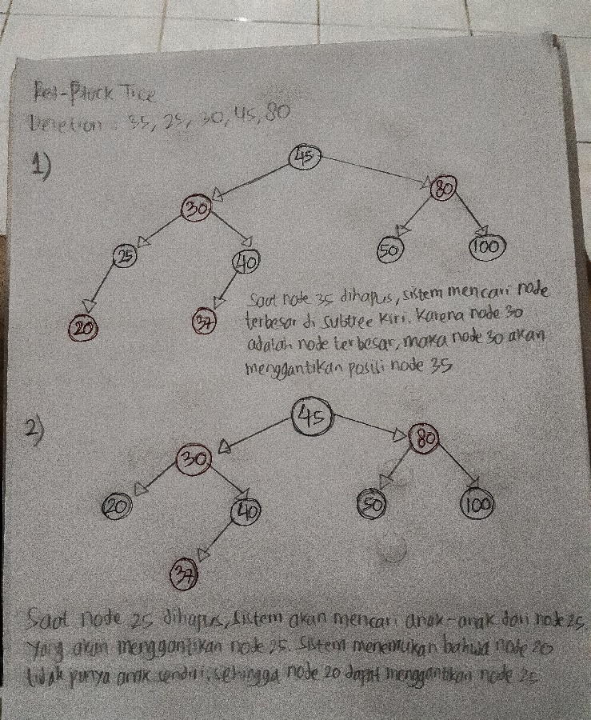

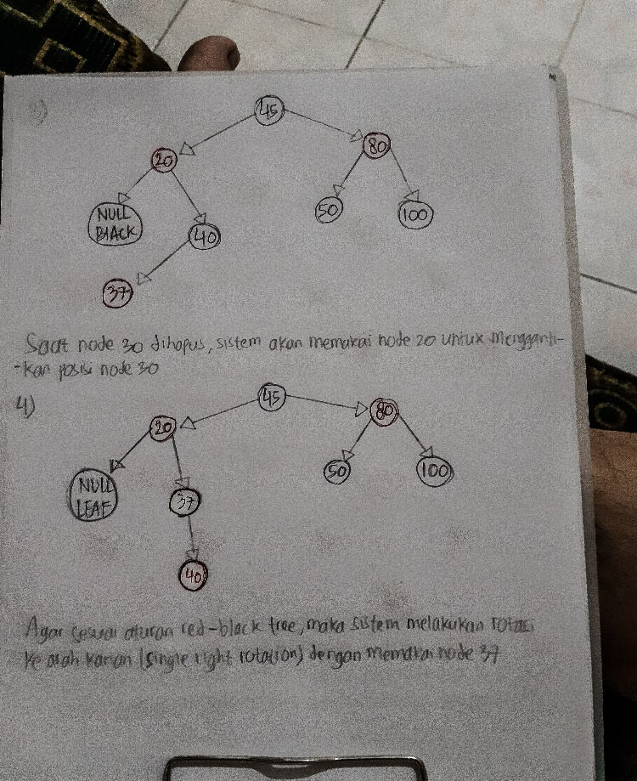

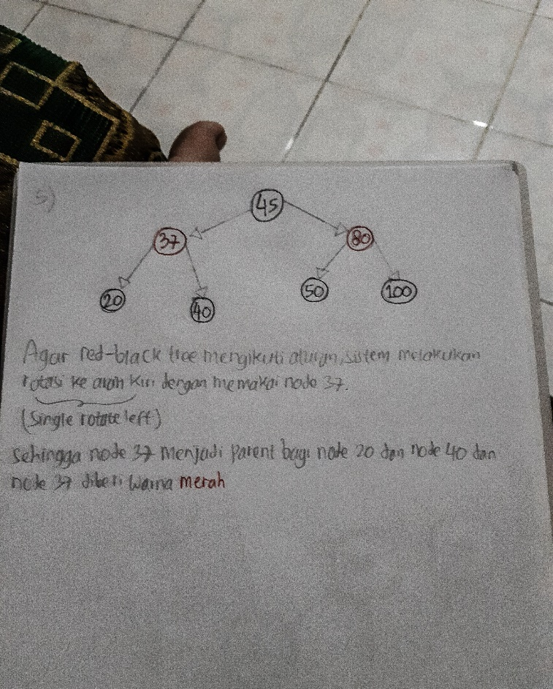

5) Disjoint Set & Graph :

Kruskal’s Algorithm :

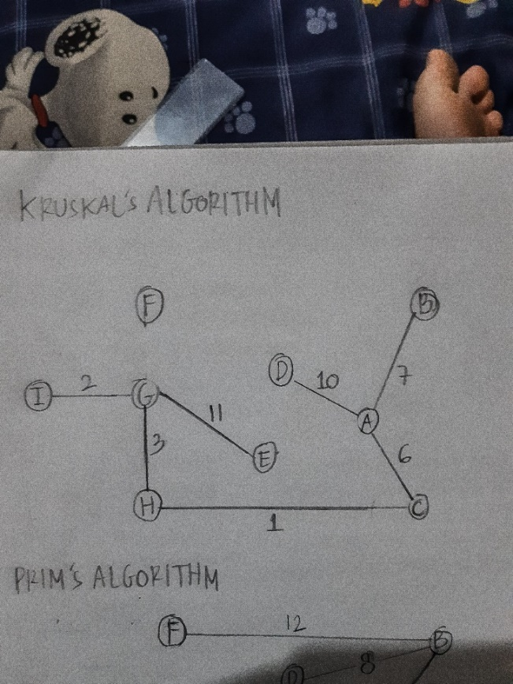

Prim’s Algorithm :

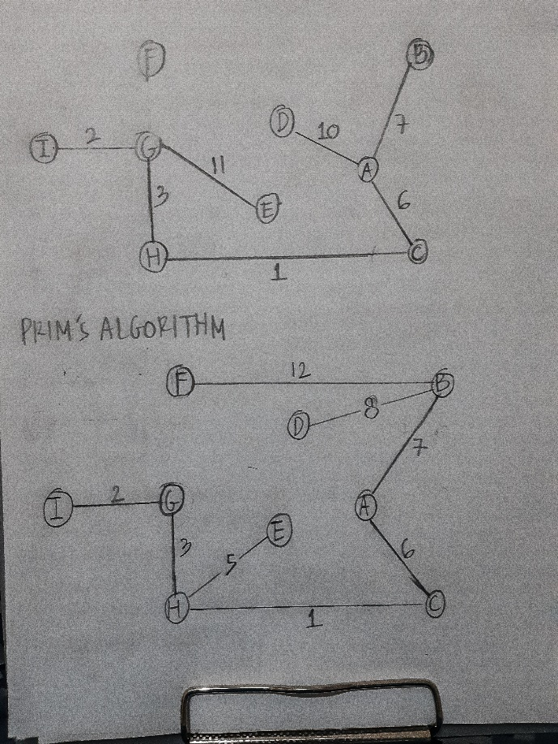

Djikstra’s Algorithm :

Shortest path from I to A :

1. {I,G} = jaraknya 2

2. {G,H} = jaraknya 3

3. {H,C} = jaraknya 1

4. {C, A} = jaraknya 6 (telah sampai tujuan)

Rute :

I 🡪 G 🡪 H 🡪 C 🡪 A

Shortest path from F to C :

1. {F,B} = jaraknya hanya 12

2. {B,A} = jaraknya hanya 7

3. {A,C} = jaraknya hanya 6, telah sampai di tujuan

Rute :

F 🡪 B 🡪 A 🡪 C